**Project Design Phase-II**

**Technology Stack (Architecture & Stack)**

| **Date** | **22/06/2025** |
| --- | --- |
| **Team ID** | **LTVIP2025TMID48146** |
| **Project Name** | | **iRevolution: A Data-driven Exploration of Apple's iPhone Impact in India using Tableau** | | --- | |  | |
| **Maximum Marks** | **4 Marks** |

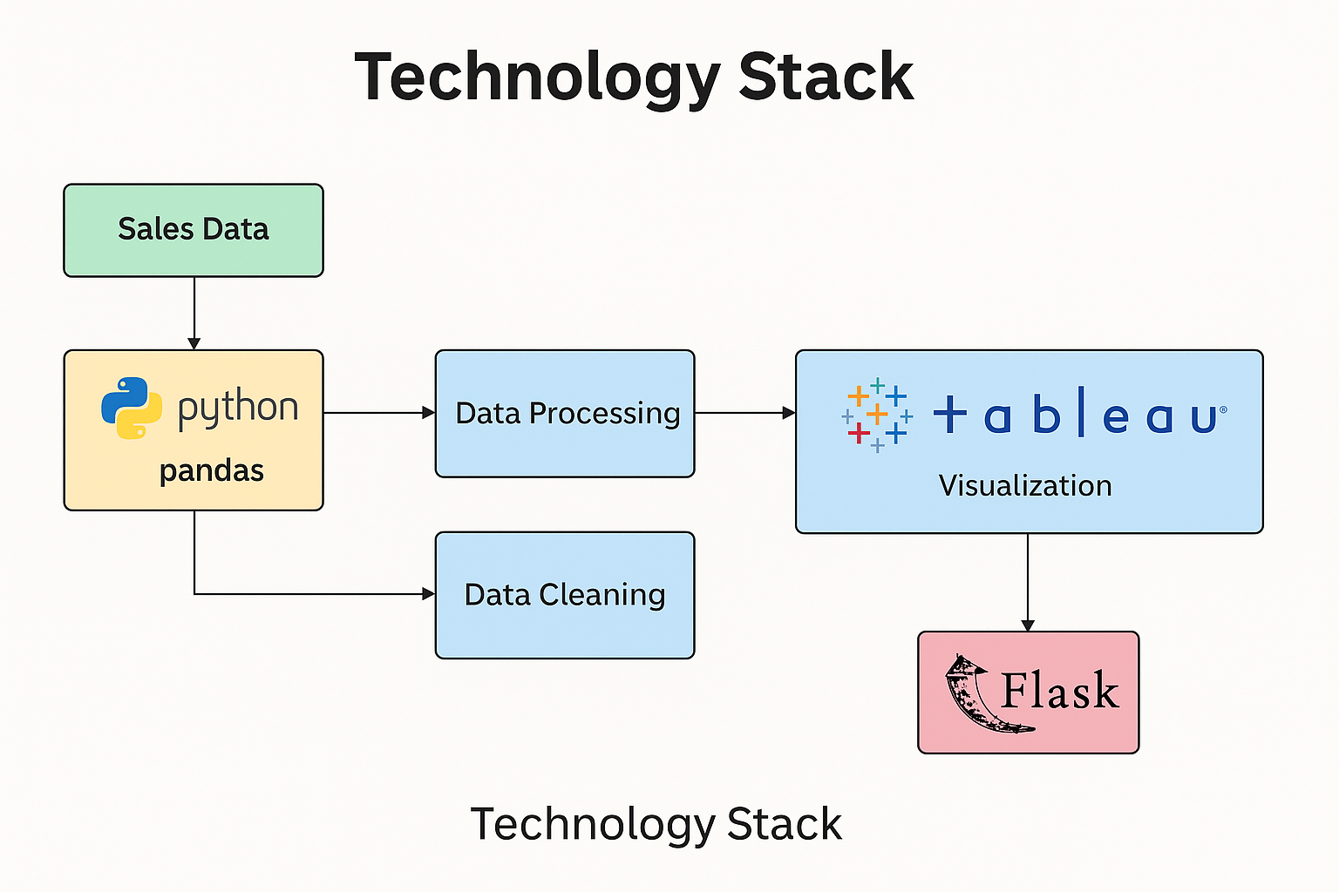

**Technical Architecture:**

| **Component** | **Description** | **Technology** |
| --- | --- | --- |
| **Sales Data** | **Source dataset from Flipkart/Kaggle containing Apple product details** | **CSV Files, Web Scraped Data** |
| **Data Loading** | **Loads the dataset into Python for processing** | **Python** |
| **Data Cleaning** | **Cleans missing values, duplicates, and incorrect formats** | **Pandas, NumPy** |
| **Data Processing** | **Filters by attributes like RAM, battery, price, and brand** | **Pandas, NumPy** |
| **Data Visualization** | **Visualizes KPIs, trends, and model comparisons** | **Tableau Public** |
| **Web Integration** | **Embeds dashboard in a responsive web interface** | **Flask** |
| **Dashboard Access** | **Allows users to interact with visual insights online** | **Web Browser, Tableau Interface** |

## **Table 2: Application Characteristics**

| **Component** | **Description** | **Technology / Implementation** |
| --- | --- | --- |
| **Open-Source Frameworks** | **Uses freely available tools for development and visualization** | **Python, Flask, Pandas, Tableau Public** |
| **Security** | **Access-controlled dashboard with optional password protection or Tableau settings** | **Flask authentication (optional), Tableau settings** |
| **Scalability** | **Modular setup allows adding more brands, regions, or data sources** | **Loosely coupled frontend–backend** |
| **Availability** | **Hosted on Tableau Public and accessible through any browser** | **24/7 via Tableau Public** |
| **Performance** | **Optimized for fast loading using pre-processed datasets** | **Lightweight CSV handling + Tableau speed** |
| **Portability** | **Can run on any system with a browser and Python environment** | **Cross-platform deployment** |
| **Maintainability** | **Easy to update datasets or enhance dashboard features** | **Modular Flask app + Tableau updates** |